

**Department of Computer Science and Engineering**

**21st Batch**

**Lab Report 2**

**Course Code: CSE 414**

**Course** T**itle: Artificial Intelligence Lab**

|  |  |  |  |
| --- | --- | --- | --- |
| **Submitted By** | | **Submitted** T**o** | |
|  |  |  |  |
| Name | : Md. Mahfujur Rahman | Name | : Salma Akter Lima |
| ID | : 192311014 | Designation | : Lecturer (Provisional)  Varendra University,  Rajshahi. |
| Section | : A |  |
| Semester | : 10th |  |
| Batch | : 21st |  |  |
|  |  |  |  |
|  |  |  |

------------

**Problem:** Creating the family tree with prolog. And determining

1. Father

2. Mother

3. Grandfather

4. Grandmother

5. Sister

6. Brother

7. Aunty

8. Uncle

9. Cousin

10. Predecessor

**Theory:** Here we will try to use Fact and Rules to define the family-tree then use queries to see if we are getting all the expected result. If we depict the graph of the family tree:

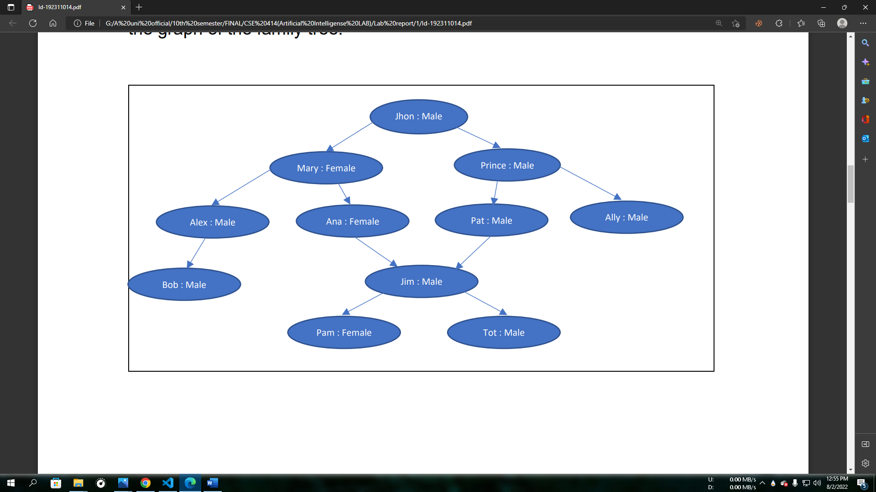

**Diagram: Illustration of the family tree of jhon.**

**Code:**

|  |
| --- |
| male(jhon).  male(prince).  male(ally).  male(pat).  male(alex).  male(bob).  male(jim).  male(tot).  female(mary).  female(ana).  female(ally).  female(pam).  parent(jhon,mary).  parent(jhon,prince).  parent(mary,alex).  parent(mary,ana).  parent(prince,pat).  parent(prince,ally).  parent(alex,bob).  parent(ana,jim).  parent(pat,jim).  parent(jim,pam).  parent(jim,tot).  mother(X,Y):-female(X),parent(X,Y).  father(X,Y):-male(X),parent(X,Y).  grandfather(X,Y):-male(X),parent(X,Z),parent(Z,Y).  grandmother(X,Y):-female(X),parent(X,Z),parent(Z,Y).  sister(X,Y):- X\=Y,female(X),parent(Z,X),parent(Z,Y).  brother(X,Y):- X\=Y,male(X),parent(Z,X),parent(Z,Y).  uncle(X,Y):-male(X),parent(Z,Y),brother(X,Z).  aunt(X,Y):-female(X),parent(Z,Y),sister(X,Z).  cousine(W,X):-parent(Y,W),parent(Z,X),brother(Y,Z).  cousine(W,X):-parent(Y,W),parent(Z,X),sister(Y,Z).  predecessor(X,Y):-parent(X,Y).  predecessor(X,Y):-parent(X,Z),predecessor(Z,Y).  cls:- write('\33\[2J'). |

**Output:**

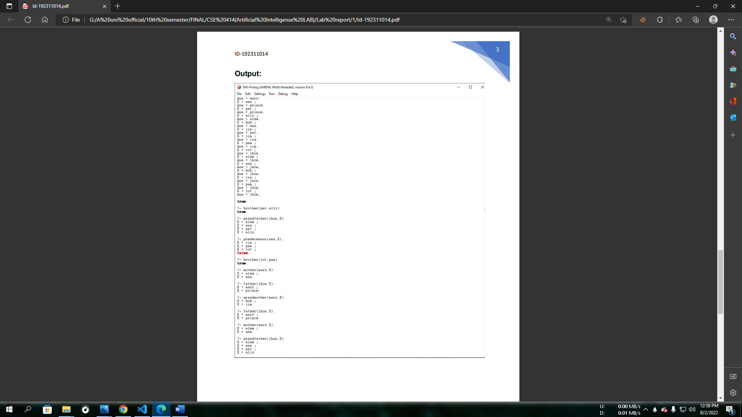

**Conclusion:** From the family-tree graph we feed information to the system and based on the information the system gives us the required output or result. we have tried to extract the required 10 questions and got the required results.